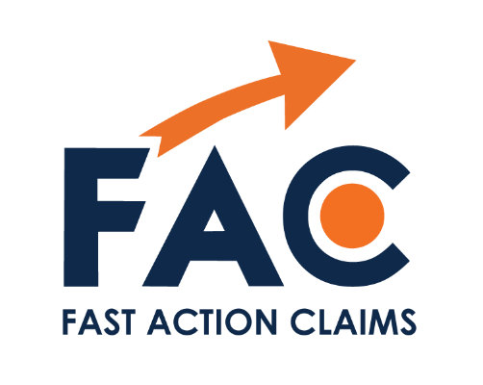
Fast Action Claims
Tel: 0161 505 0150
1.03 The Boat Shed
12 Exchange Quay
Salford, M5 3EQ
dsar@fastactionclaims.co.uk
Date: {{Today's Date}}
Our Reference: {{Client ID}}
Client Name: {{Full Name}}
Lender: {{Lender}}

Subject: Request for Disclosure of Client Information – Data Subject Access Request
Dear Sir/Madam,
We act on behalf of the above-named client.
We formally request that your organisation promptly disclose and release to Fast Action Claims all documentation and information relating to our client's financial arrangements with your institution. This includes, but is not limited to, all data and records regarding loans, credit cards, borrowing, and account activity.
Specifically, we require a complete file containing:
True copies of all completed application forms
All pre-contractual information and documentation provided
Executed copies of credit or loan agreements
Full statements of account, detailing all payments made, interest charged, fees incurred, and any outstanding balances
Documentation showing any amounts currently payable or remaining unpaid under the agreements
Affordability and creditworthiness assessment records conducted during the application process and throughout the agreement’s term

All documentation or correspondence in relation to any previous complaints lodged including copies of any final response letters
This request is made under the UK General Data Protection Regulation (UK GDPR) and the Data Protection Act 2018. We remind you that you are obligated to respond to this request within one calendar month from the date of receipt.
Please forward all requested information directly to our office at the address shown above, or via email to dsar@fastactionclaims.co.uk.
Should you require verification of our authority to act on behalf of our client, please find enclosed the signed Letter of Authority.
We look forward to your prompt response.
Yours faithfully,

Fast Action Claims

